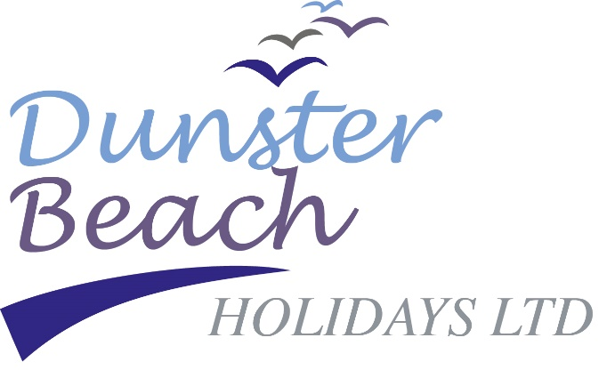

Welcome to Dunster Beach
We are delighted to welcome you to Dunster Beach. After a challenging year for all, I do hope you can find some peace and tranquillity in our special corner of Exmoor.
Please be mindful of social distancing whilst on site and let us all ensure we do our part to keep everyone on site Covid safe.
Should you have any questions or if there is anything, we can advise you on then please do not hesitate to call the office on 01643 821296 and we will do our utmost to help you.
In your welcome pack, we have given you the key information regarding your stay and the site. Please read everything in its entirety and discard when you vacate.
The vehicle pass needs to be completed and displayed in clear view in your vehicle whilst on site.
Please return your Test & Trace form to the office as soon as possible. If the office is closed please put in the site letter box at the top of the ramp outside the office.
We have included a black refuse sack. Please place in your bin and take to the bin store/recycling centre when you leave.
The café is now open and operating a take away service, please check for opening hours.The kiosk is operating a small shop for essential grocery items and is also offering drinks, snacks and ice cream, including local Styles ice cream, which is made in Rodhuish just up the road. The kiosk is on the main green just by the putting green.
Please familiarise yourself with the rules of the beach which are displayed in your chalet and are available on our website. The rules are designed to ensure everyone has a safe and incident-free holiday.
Please vacate your chalet by 10am at the latest on the day of departure, and that you leave the chalet as you found it. Remember to take all your possessions home with you and drop off your rubbish and recycling at the centre situated behind the office.
Have a very happy holiday.

Regards,

Steve Pearson
Beach General Manager

