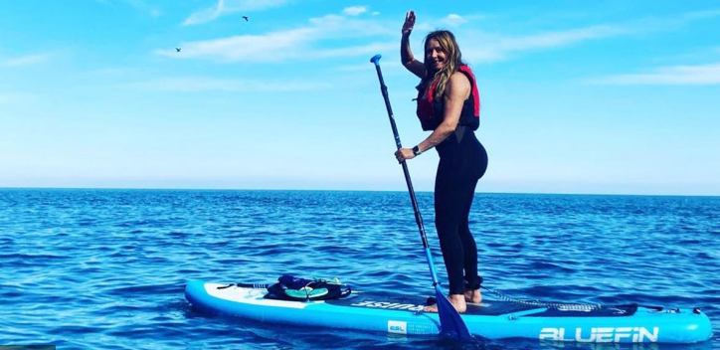

Top water safety tips for Stand Up Paddleboarding - PLOT your paddle
- Personal Floatation Device - Always wear a buoyancy aid - if you fall into the water it will help you float and keep your airway clear
- Leash - Use an ankle leash for surf or non-flowing water and a quick release waist-belt leash for flowing water or tidal waterways
- Offshore Winds - Check the weather conditions, taking note of local currents and the wind direction - DO NOT paddle in offshore winds
- Telephone - Take a mobile phone with you in a waterproof pouch, if you are in trouble - call 999. Ask for the Coastguard.

Further tips for your SUP session
- If you get into difficulty, stay on top of your board and signal for help
- If you fall into the water and lose you board - Stay calm, float on your back and call for help
- Let somebody know where you are heading and what time you're due to be back
- Paddle with somebody else, it's more fun and they can help in an emergency
- Understand your capability in the conditions, if you're unsure paddle another day
- Stay clear of swimmers and other paddlers

If you see someone in trouble

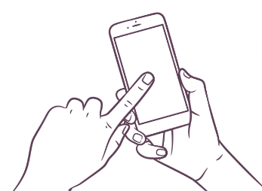
Don’t delay call 999

