Local Eateries to try
Minehead
Golden House (Chinese) 01643 702723
Taj Mahal (Indian) 01643 704857
Alcombe Tandoori 01643 706591
Fausto’s (Italian) 01643 706372
Hairy Dog 01643 704660

Dunster
Cobblestones 01643 821595
Luttrell Arms 01643 821555
Hathaways 01643 821725
Reeves Restaurant 01643 821414

Further afield
Smugglers Inn, Blue Anchor 01984 640385
Ralegh’s Cross 01984 640343
White Horse, Exford 01643 831229

And to get you there

Ava Cabs 01643 703333
Alcombe Taxis 01643 702269
Exmoor Taxis 01643 863355
Minehead Taxis 01643 707766
Minehead Taxis (7 Seater) 01643 704123
Minehead Taxis (Wheelchair Accessible) 01643 704000

Places of Worship in Minehead and Dunster
Minehead
St Andrew’s Church - Wellington Square
St Michael’s Parish Church - North Hill
St Peter’s on the Quay - Minehead Harbour
Quaker Meeting House - Bancks Street, Minehead
Sacred Heart Church - Townsend Road, Minehead
Methodist Church - The Avenue, Minehead
Baptist Church - Parks Lane, Minehead
United Reform Church - Bancks Street, Minehead
Millbridge Evangelical Church - Parkhouse Road, Minehead
Kingdom Hall - Mart Road, Minehead

Alcombe
The Christian Spiritualist Church - Manor Road, Alcombe
Alcombe Evangelical Church - Hopcott Road, Minehead
Alcombe Methodist Church - Lower Meadow Road, Alcombe
St Michael the Archangel - Church Street, Alcombe

Dunster
St George’s Parish Church - Dunster

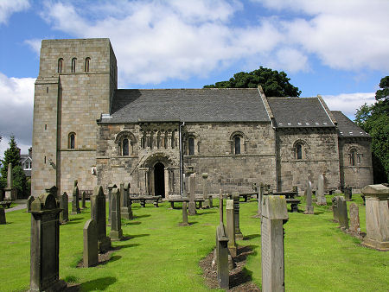

The West Somerset Free Press, available from the shop, publishes times of services

