

CHALET 250 FOR SALE

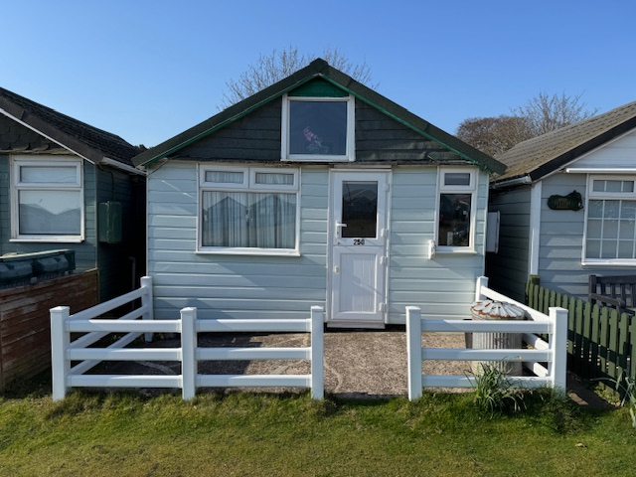

Chalet 250 is situated by the lake just by the main green. It is an ideal location for peaceful days, making memories at this beautiful well maintained site. The views of the lake from the rear garden are stunning at any time of the year.
The chalet is sold with all the fixtures and fittings included.

Externally the Chalet is of plastic cladding. Double glazed windows, single door to the rear & a stable door to the front. The front and rear of the chalet are secure and well-maintained fencing & gates. The roof is of a modern material & is in a sound condition.

The Front of the chalet has a concrete slab. This offers space for outside seating and a storage box. Parking is directly outside the chalet. A bin and recycling box are located at the front of the chalet.

Internally On entering the chalet from the front you walk into the kitchen, equipped with a hob, refrigerator and combination oven. Plenty of storage that houses the kitchen utensils, crockery and cutlery.
To the left there is a separate bedroom which has a double bed and chest of drawers
Through the kitchen you enter the lounge area, which is deceptively spacious, consisting of a sofa bed , comfy chairs and dining table. There is plenty of overhead storage.
There is a separate WC and sink accessed from the lounge.
A beautiful stain glass window is a lovely feature in the lounge.
There is plenty of natural light coming into the lounge, from half sized windows, which really makes this room so bright.
A single door leads out onto the patio area, which is gated.
The view from the back patio is stunning as you look across to the lake.

The chalet is reduced to £175,000

Payment to Dunster Beach Holidays
A fee equivalent to 1.5% of the purchase price and a £50 administration fee are payable to Dunster Beach Holidays. Both fees are subject to VAT.

To view the property or for further information, please contact the office on 01643 821296 or
email information@dunsterbeachholidays.co.uk

