CHALET 21 SALE DETAILS
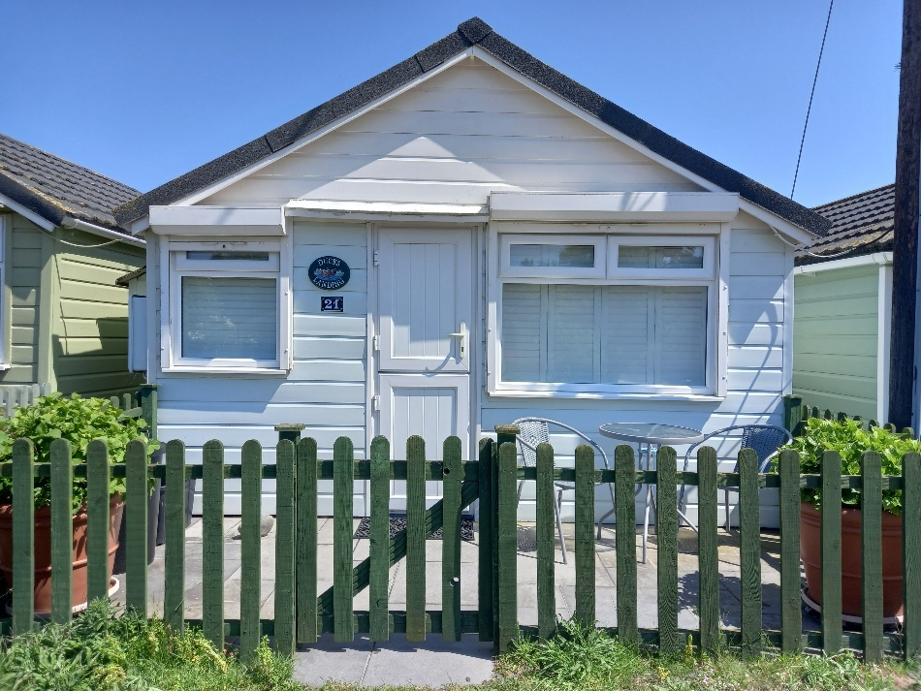

Chalet 21 is beachside and has sweeping, uninterrupted views of the sea and the Welsh coastline. Beautifully decorated and designed the chalet is being sold with all contents included in the sale.
The front and rear patios have high quality paving and both benefit from all-weather patio dining sets, newly purchased for the 2023 season. "The solid stable door opens onto the kitchen, which was fully refurbished in January 2025. All the plumbing and outside pipework was replaced at the same time, and the front and rear elevations painted with high quality outdoor paint in March 2025.
The lovely new kitchen has a brand new cooker and a fridge. The microwave, kettle, toaster, breadbin and kitchen bin are all in a matching shade of blue."
Base and wall units have all the usual cooking utensils and there is crockery and glassware for four. On the right is the bedroom with double bed having a comfy memory foam mattress, chest of drawers with bedside lamp and mirror above. Plantation shutters stylishly form the dividing wall between the bedroom and the lounge area allowing for complete privacy when fully closed but also allowing for the option to fully or half open to allow air and light to circulate through both rooms.
Large patio doors with electrically operated security shutters lead onto the beachside patio from the lounge area, which has a double, deep mattress sofa bed, recently fitted carpet, table and chairs, oak nest of tables and a wall mounted television. The efficient heater is also wall mounted. Off the lounge is the shower room with waterproof panelling to walls, with toilet, vanity unit with washbasin, and newly fitted water heater. The shower is tiled with concertina doors. A very desirable chalet that is ready to move into for your own personal use or as a very marketable holiday letting option.
This chalet is further reduced to £190,00
Payments
1.5% of the purchase price plus VAT, is payable to Dunster Beach Holidays on the purchase of the chalet.

