Chalet 221 For Sale
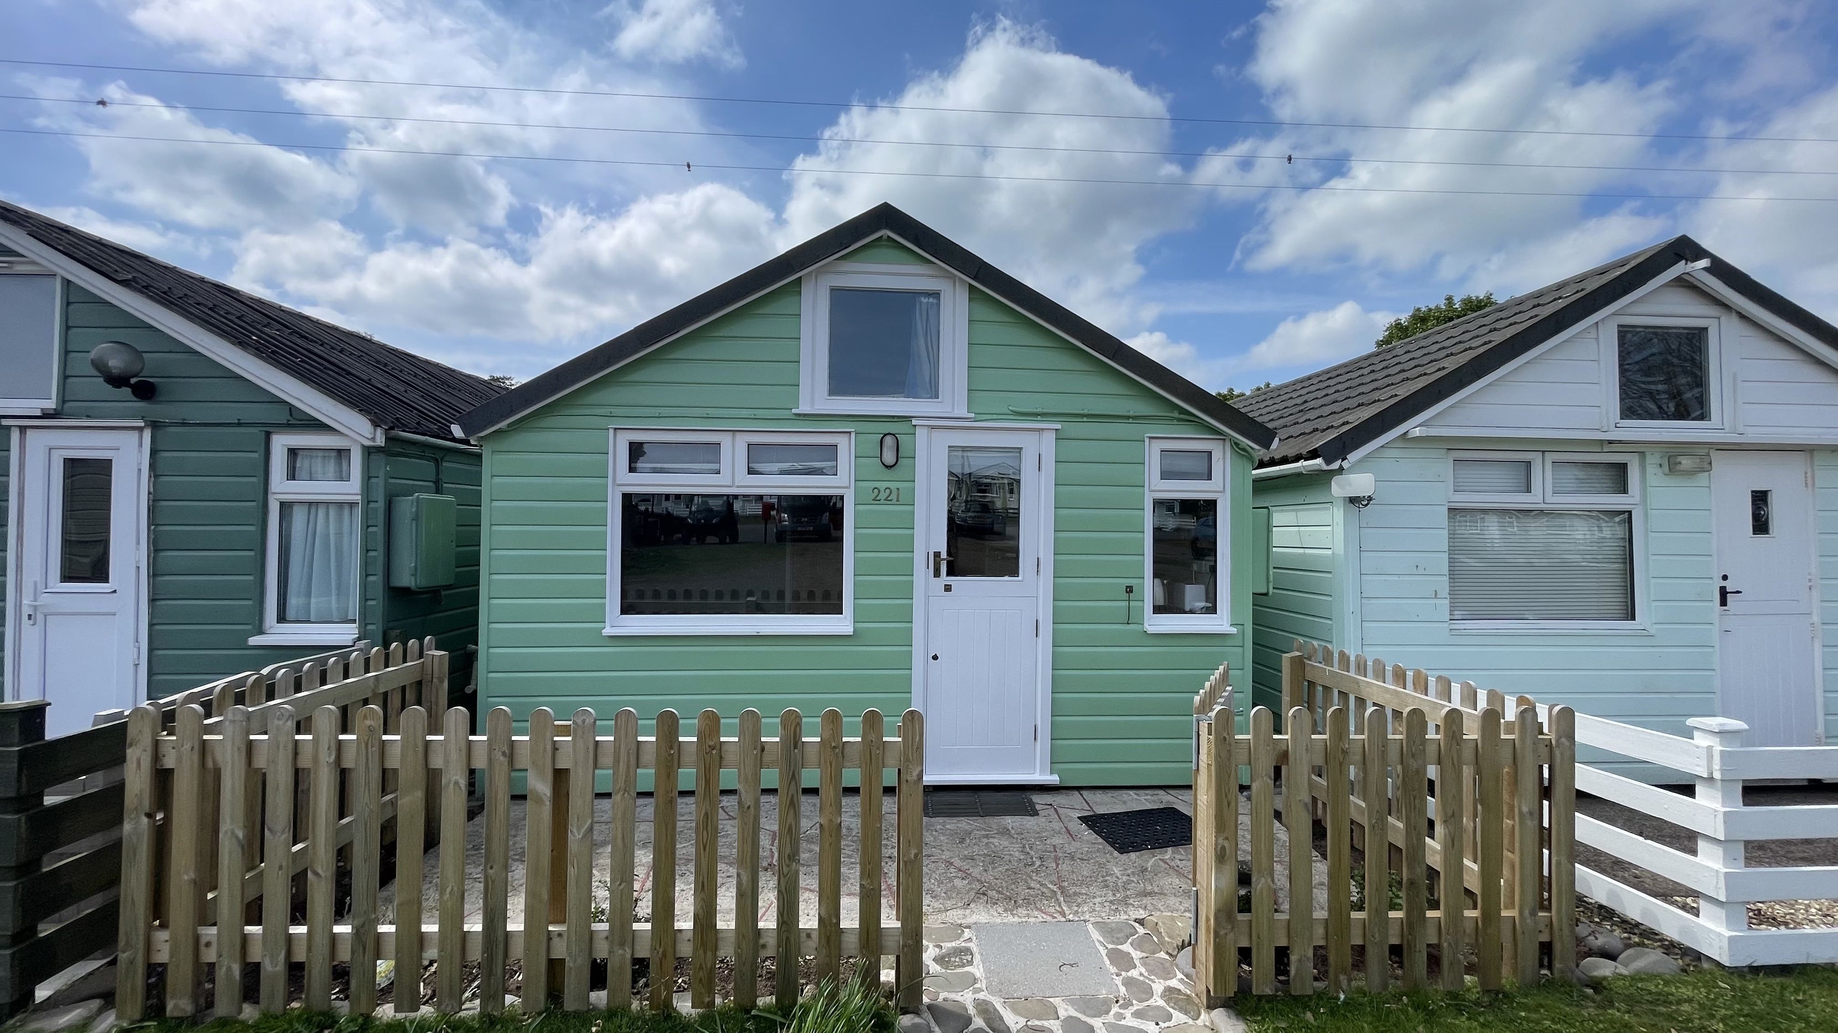
This lovely beach hut has been in our family since 1997. During this time it has been extremely well maintained and has a hand-built ergonomic internal design that can accommodate 5 adults and two children.

It is situated lakeside in a very convenient spot behind the shop, across the green from a shower block and just a minutes stroll from the tennis courts. There is parking available directly in front of the hut.

Exterior:

The exterior walls of the hut are traditional wood shiplap and are fully insulated. The roof is recently renewed bitumen felt.
The hut has a sturdy fence with recently installed patio slabs and new plantings and lawn.
The original rear doors and frame have been renovated including a hardwood sill. The front door is a split design with the top half separately openable. All the front windows are UPVC double glazed. All external woodwork has been renovated last year.

Rear Garden:

The rear garden has flower beds around the edge and patio adjacent to the hut. There is functional garden furniture and a practical storage box for tennis/garden equipment and a parasol.

Interior

The main upgrade to the interior was completed in 2010 with fitted cupboards, upstairs sleeping provision for two kids, granite kitchen worktops and new plumbing fittings. This sturdy design has been redecorated last year.

Kitchen:

This space is fitted with a deep sink, and microwave on a shelf out of the way.
There's an ingenious space-saving cupboard that makes use of the space between the huts for dinnerware. Hot water is supplied to the whole hut from a small storage tank hidden away at floor level in the bathroom. When cooking you can chat to your kids on the mezzanine floor above the bedroom to the side of you

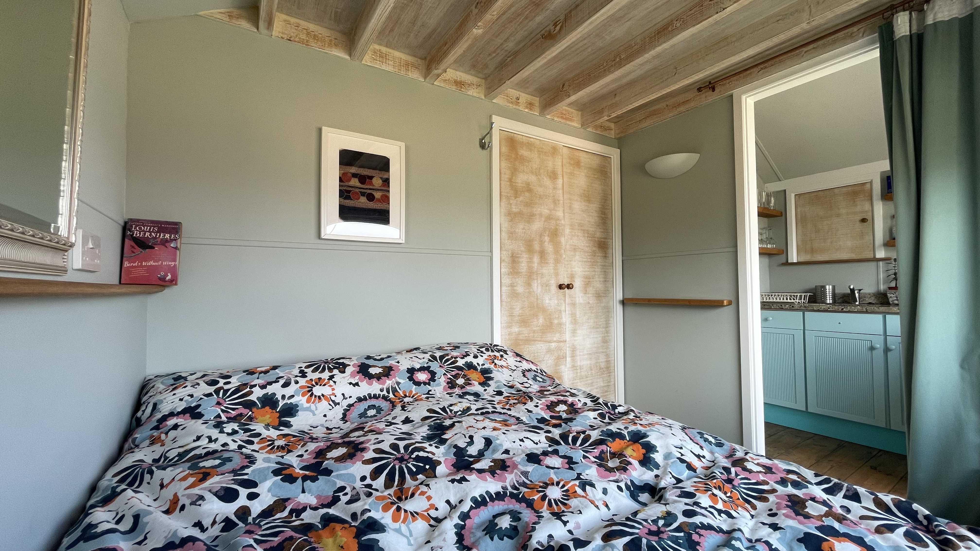
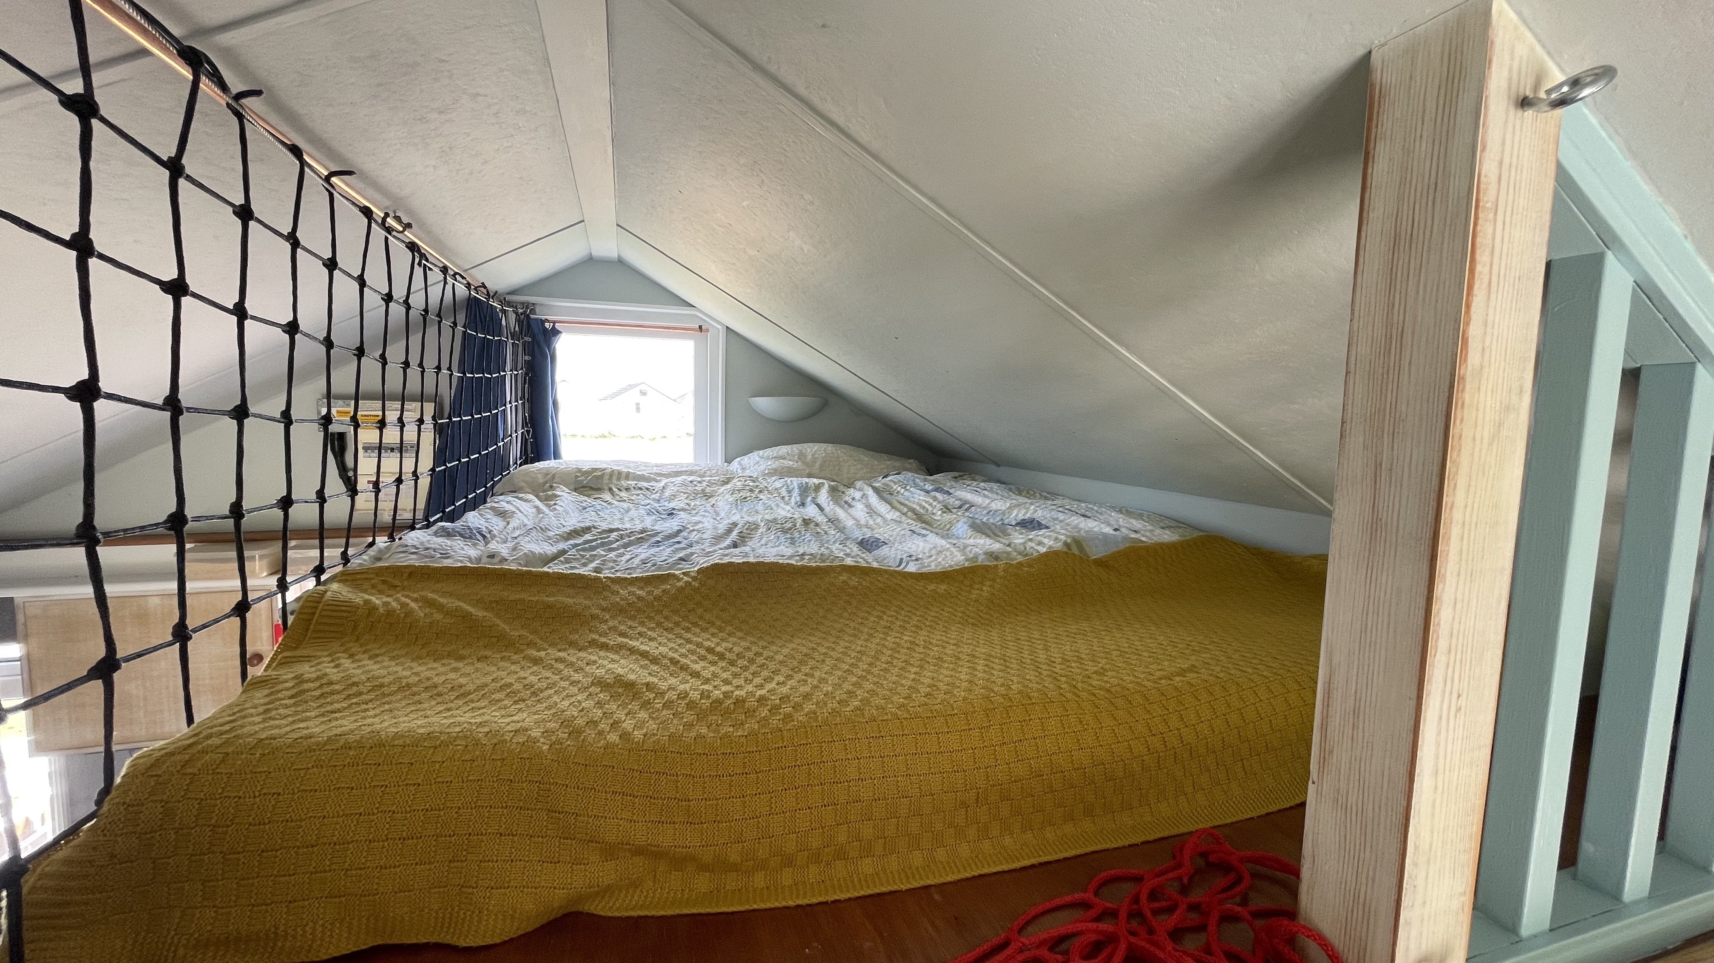
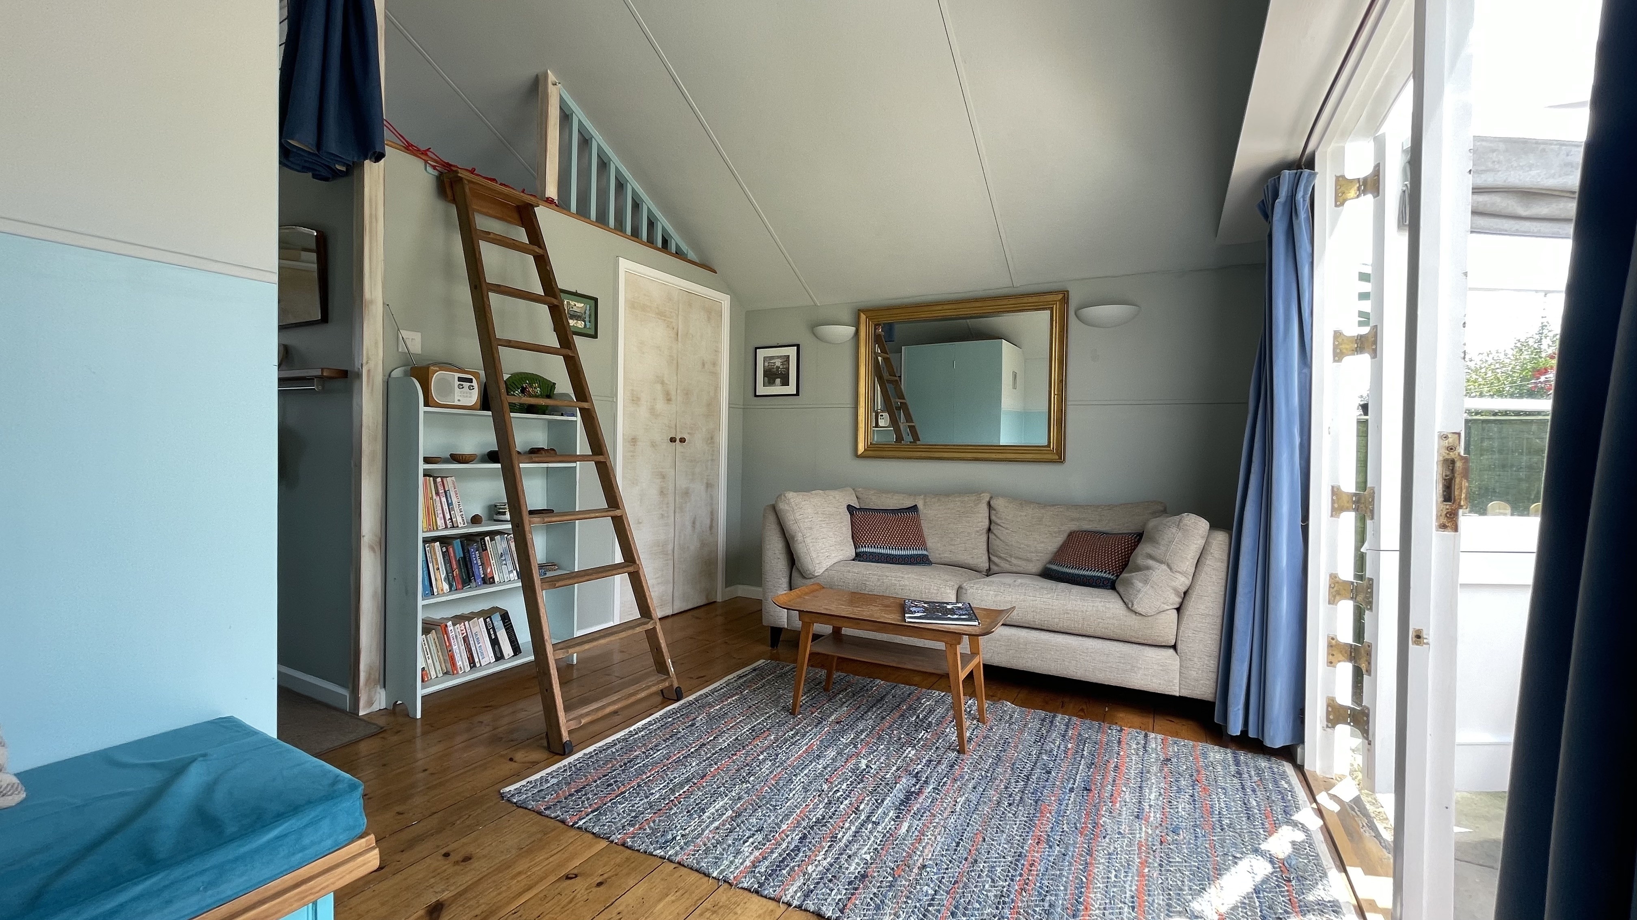
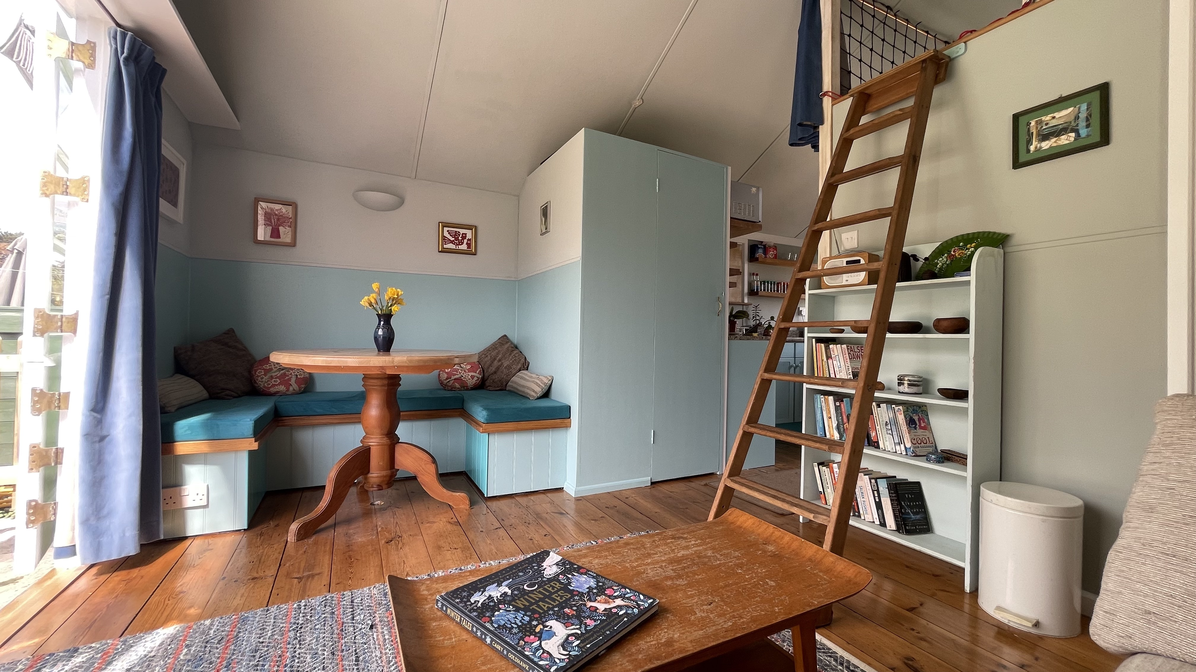
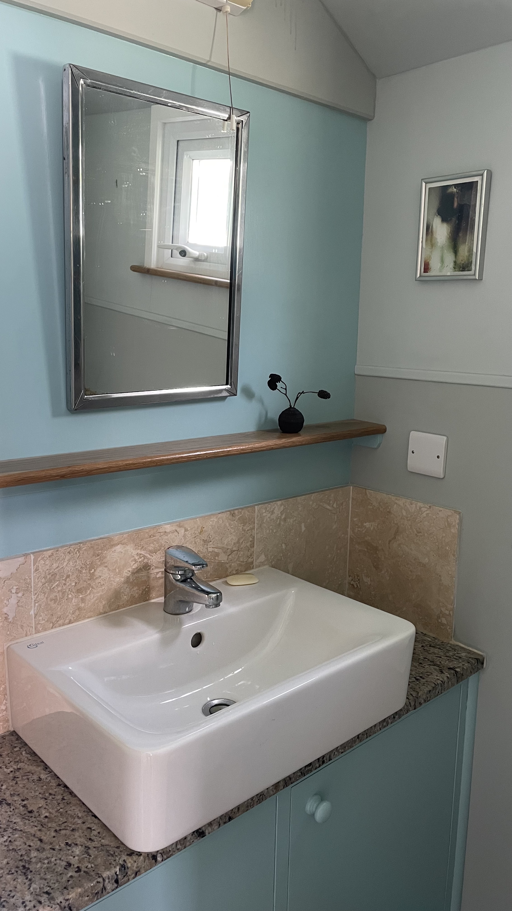
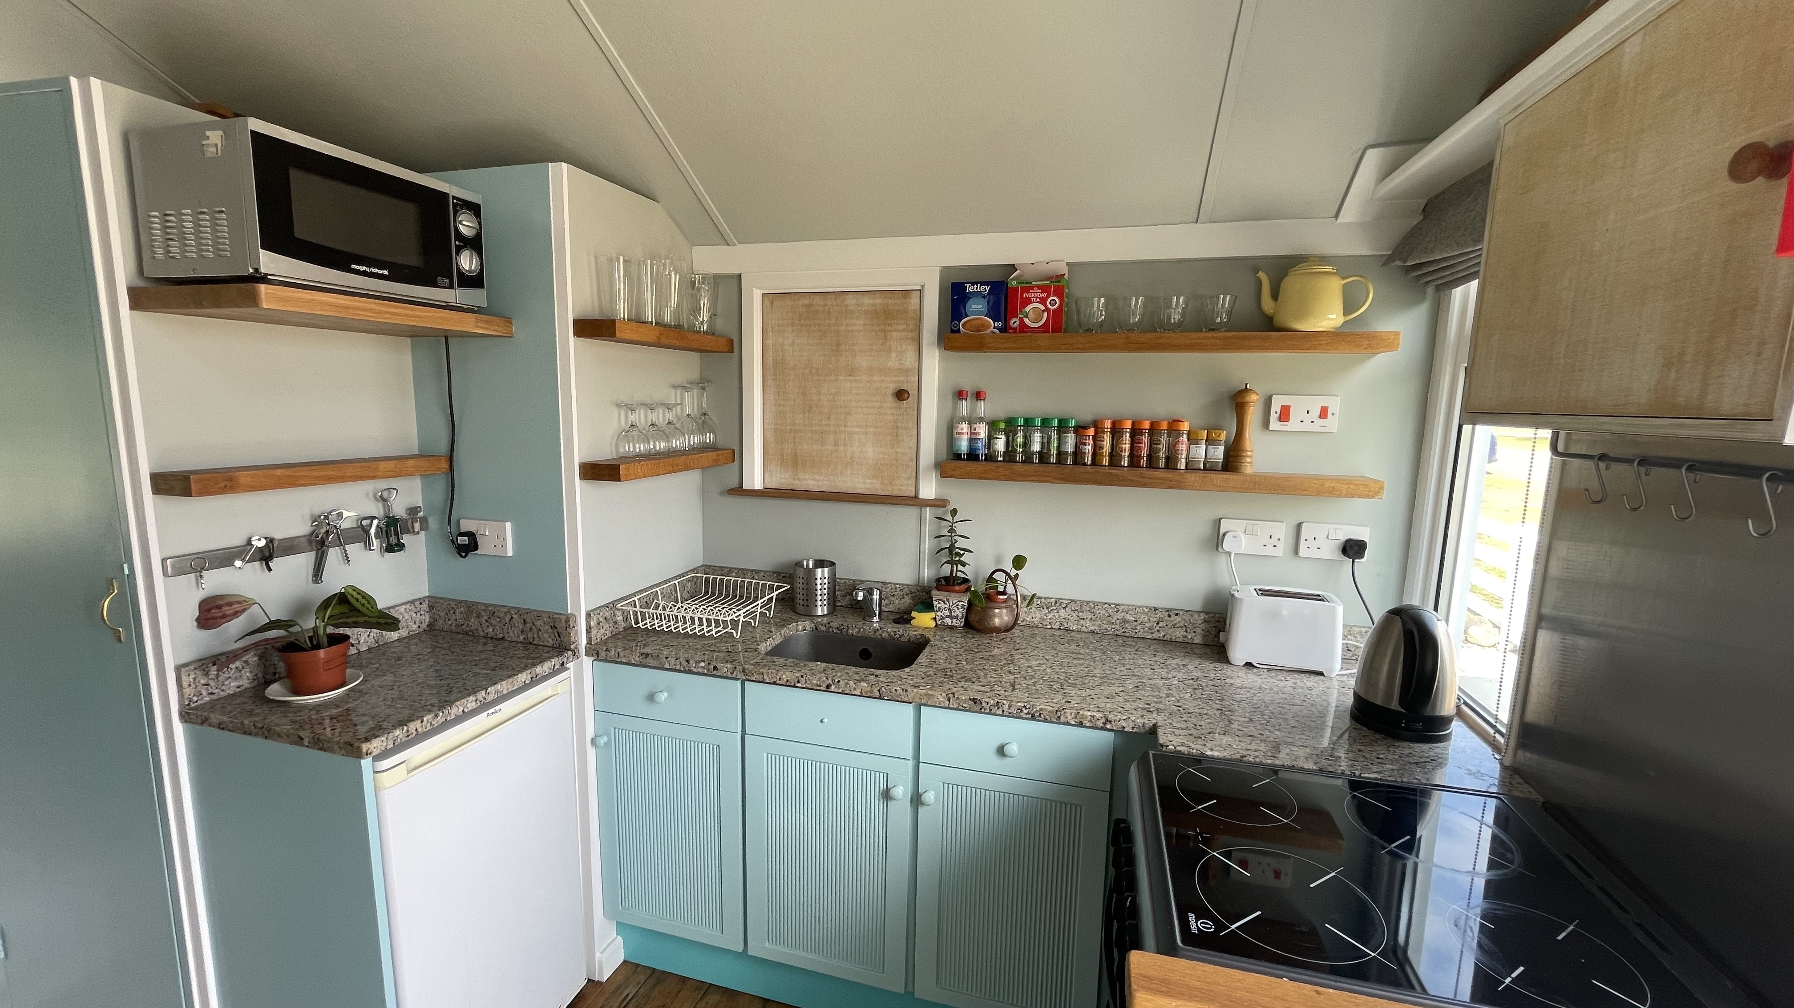

Bedroom:

The hut has a bedroom at the front with a curtained doorway to allow occupants of the double bed to sleep away from main living space. Access to full height fitted cupboards are available in this space as well as deep drawer storage under the bed. There is a bookshelf as well as a handy plug socket by the bed.

Dining/Living area:

The dining table has a fitted seating area around it to make best use of the space. These benches turn into a small but cozy double bed using a handy piece of cushioned ply that is stored on top of the adjacent ceiling area. Under the benches there is extra storage space.

There is a sofa and small table for games etc around which we have spent many happy hours. This space has a set of French windows which open out to the back garden for an open feel on sunny days. This area provides a really cozy space even off-season and the proximity to the shower block across the green is a boon during this time. More fitted cupboards are available in this area.

Mezzanine:

There's a ladder that's tied into the wall for kids to get up to this. Alternatively this space is fine for one adult to sleep. A curtain can be drawn across to separate this area from the kitchen below. There is a net to hold children in at the top of the ladder.

Toilet:

Furnished with modern space-saving fittings and a built-in shelf, this area feels surprisingly luxurious for such a small space with sturdy tiling and attention to detail in the design. There's a switch for the hot water at floor level. The mini hot water storage tank is in the cupboard. The toilet is recessed into the L-shaped room corner.

The chalet has a full maintenance history dating back to 1999.

Offers in the region of £185.000

Payments A fee equivalent to 1.5% of the purchase price and a £50 administration fee are payable to Dunster Beach Holidays. Fees are subject to VAT.
To view the property please contact the office on 01643 821296 or email information@dunsterbeachholidays.co.uk

