Chalet 156

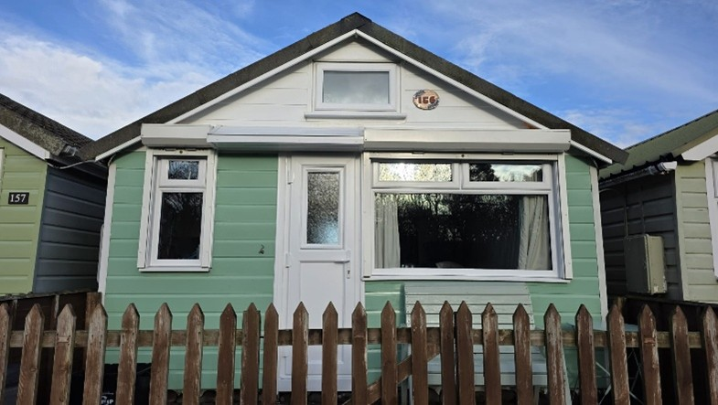

Chalet 156 occupies a peaceful beach-facing spot at the far end of the site. The chalet and pebble-walled sea front garden both allow for beautiful panoramic sea views with a new patio installed in 2024. There is also a fenced front patio with further seating.

Inside, the property comes fully furnished with all cooking utensils, crockery and cutlery included. The fitted kitchen includes an electric fan assisted cooker, fridge, microwave, toaster and kettle. Hot running water is supplied from a newly installed under-sink hot water heater fitted in December 2025.
The property is open plan, maximising space and light with a double sofa bed in the living area with an additional lounger chair. Chalet space can be configured to accommodate a separate sleeping area with an additional bed. Additional furniture included is a wardrobe, tallboy chest of drawers, nest of tables and dining table and chairs.
The bathroom benefits from its own toilet, sink with small hot water heater and electric shower.
Double glazed throughout with a newly fitted front door in 2024. The chalet is well maintained and is ready to move into. The chalet is currently connected to Airband Wi-Fi, with an external receiver and internal router. The contract for the Wi-Fi expires in spring 2027, Airband have advised the new owners can take over this contract if they wish to continue to have Wi-Fi to the chalet, further information is available as needed.

This chalet is for sale at £200,000

Payment to Dunster Beach Holidays
A fee equivalent to 1.5% of the purchase price and a £50 administration fee are payable to Dunster Beach Holidays.
Both fees are subject to VAT. To view the property or for further information, please contact the office on 01643 821296 or email information@dunsterbeachholidays.co.uk


