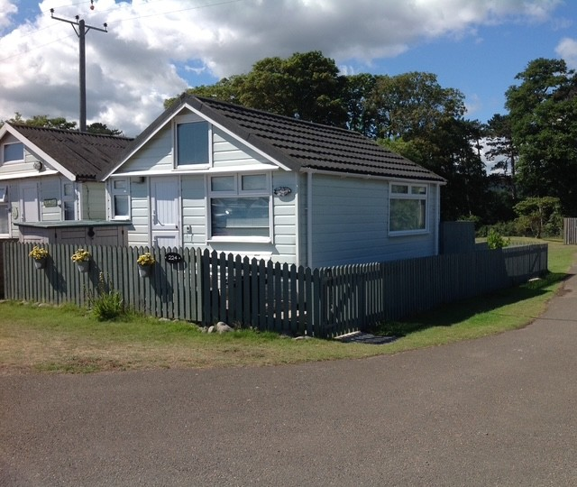
Chalet 224 'Pebbles' This Lakeside positioned End Chalet overlooking the Tennis Court, is quietly and conveniently located close to the Main office, Recycling area and Shower block in the middle of the Dunster Beach complex.
This well-appointed traditional Chalet comprises of –
- A open plan arrangement beginning with the Kitchen area at the entrance of the Chalet complete with Fridge Freezer, Oven, Microwave and essential cooking utensils.
- Enclosed Toilet and sink.
- Main living area comprising of a pull out bed double bed, folding dining table with stools. Bunk beds, with an additional side window for extra light, as it is an end Chalet. And Double Doors opening out to the patio at the rear of the Chalet.
To the outside there is parking for several cars at the front and side of the chalet, with a good sized patio at the back with table and chairs.
- Recent improvements include a new front double glazed window and Kitchen.
- The chalet is sold with all fixtures and fittings.
This Chalet offers comfortable and relaxing accommodation, close to the necessary amenities with in Dunster Beach complex and allowing one to escape the trappings of modern life and enjoy a well-earned Holiday.

Payment to Dunster Beach Holidays
A fee equivalent to 1.5% of the purchase price and a £50 administration fee are payable to Dunster Beach Holidays.
Both fees are subject to VAT. To view the property or for further information, please contact the office on 01643 821296 or email information @dunsterbeach holidays.co.uk
The chalet is for sale at £159,000

