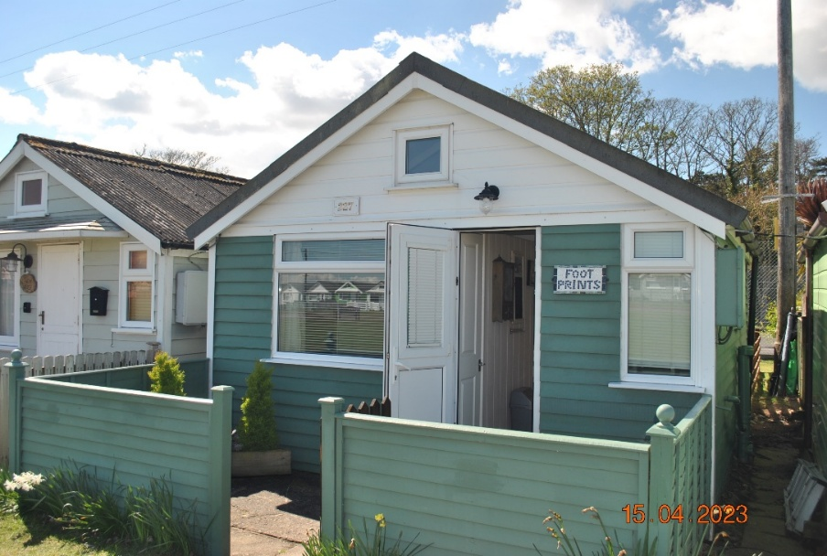

Chalet 227 ‘Footprints’
This Lakeside positioned Chalet overlooking the tennis court, is quietly and conveniently located close to the main office, recycling area and shower block in the middle of the Dunster Beach complex.
This well-appointed traditional Chalet comprises of -
- A separate kitchen area at the entrance of the Chalet complete with fridge/freezer, oven, micro wave and essential cooking utensils.
- Front separate bedroom with door access
- Shower room with toilet and sink
- Cupboard with hanging space
- Main living area comprising of a pull out bed settee, television, folding dining table with chairs. - Double doors opening out to the patio at the rear of the Chalet.
To the outside there is parking at the front and a good sized patio at the back with table and chairs.
- Recent improvements include new double glazed back doors and a bathroom window.
This Chalet offers comfortable and relaxing accommodation, close to the necessary amenities within the Dunster Beach complex and allowing you to escape the trappings of modern life and enjoy a well-earned Holiday.
The Chalet is sold with all fittings and fixings.

Payment to Dunster Beach Holidays
A fee equivalent to 1.5% of the purchase price and a £50 administration fee are payable to Dunster Beach Holidays.
Both fees are subject to VAT. To view the property or for further information, please contact the office on 01643 821296 or email information @dunsterbeach holidays.co.uk
This Chalet is for sale at £159.000

