Chalet 246 for sale
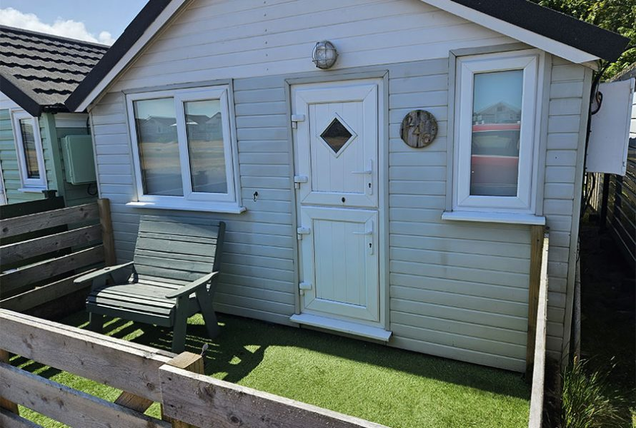

Chalet 246 - Is a Lake side chalet which comfortably sleeps 4.
The chalet has a fenced front garden with ranch style fencing.
Entering through the front door, you enter the kitchen area which is equipped with a cooker, hot water, fridge, and microwave along with cupboard space.
This then opens out further to a living area with large corner sofa which converts to a good size double bed.
In the lounge area there is a TV and a second sofa, a chest of drawers and a wardrobe for storage of clothes.
A separate segregated bedroom area has bunkbeds and a chest of draws and wardrobe. Patio doors lead to the garden which has astroturf and a 4-seat patio set overlooking the lake with passing ducks and geese.
There is no toilet or shower but the very well maintained toilet and shower block is only a short walk away. Not having these facilities affords more space in the chalet, and makes the chalet feel very spacious.
This chalet is to be sold as seen with all furniture etc included in the price.
The Chalet is offered for sale at £170,000
Or nearest offer.
Payment to Dunster Beach Holidays
A fee equivalent to 1.5% of the purchase price and a £50 administration fee are payable to Dunster Beach Holidays.
Both fees are subject to VAT. To view the property or for further information, please contact the office on 01643 821296 or email information @dunsterbeach holidays.co.uk

To view the property please contact the office on 01643 821296 or email information @dunsterbeach holidays.co.uk
