Chalet 120
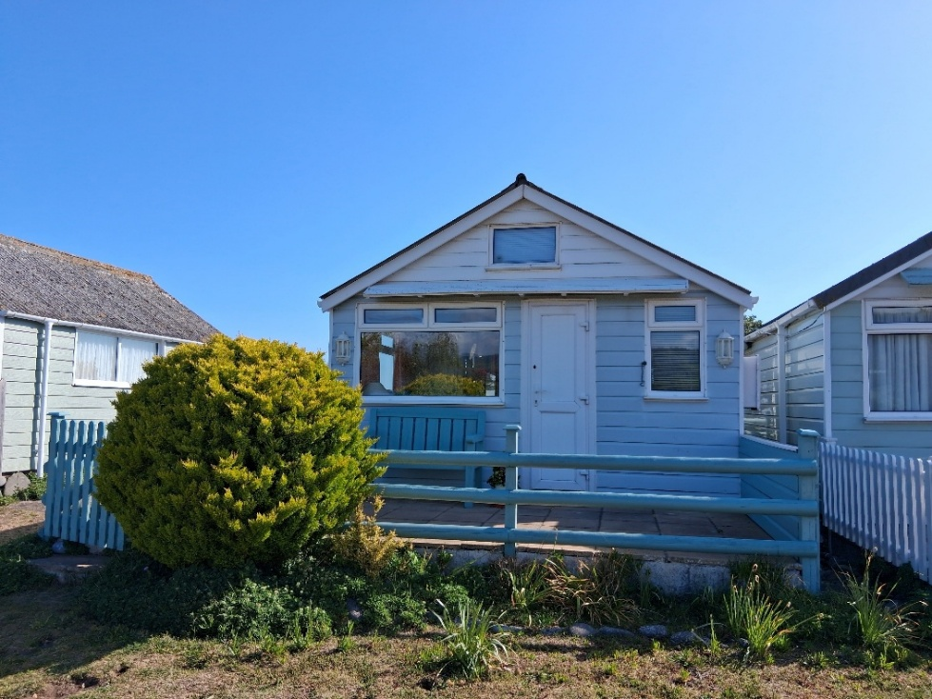

Chalet 120 occupies a prime position on the sea side of Dunster Beach. It has uninterrupted views of the lake and countryside to the front and sea views and the Welsh coastline to the rear.

Outside
The Chalet is on a large plot with a side walkway to the rear garden. It is surrounded by ranch fencing to all sides with a raised patio and bench to front and patio and gravel garden with tree and shrubs to rear.
There is a large grassed area to the front for ample parking.
The chalet has UPVC cladding, of which is very durable.

Interior
The Chalet is open-plan style with patio doors to the rear.
The kitchen comprises of a full oven/hob, microwave, fridge, sink and drainer with electric water heater above and a selection of cupboards and units.
Adjacent is a dining area with bistro table and chairs.
The sitting area features a double sofa bed and wardrobe and cabinet with TV over.
There is also an electric wall mounted heater.
Off the sitting room is a toilet and basin with electric water heater and also a wall mounted panel heater.
The shower unit is separate and fitted with a Mira system.

Price £185,000
Payment to Dunster Beach Holidays
A fee equivalent to 1.5% of the purchase price and a £50 administration fee are payable to Dunster Beach Holidays. Both fees are subject to VAT
To view the property or for further information, please contact the office on 01643 821296 or
email information@dunsterbeachholidays.co.uk

