Chalet 200

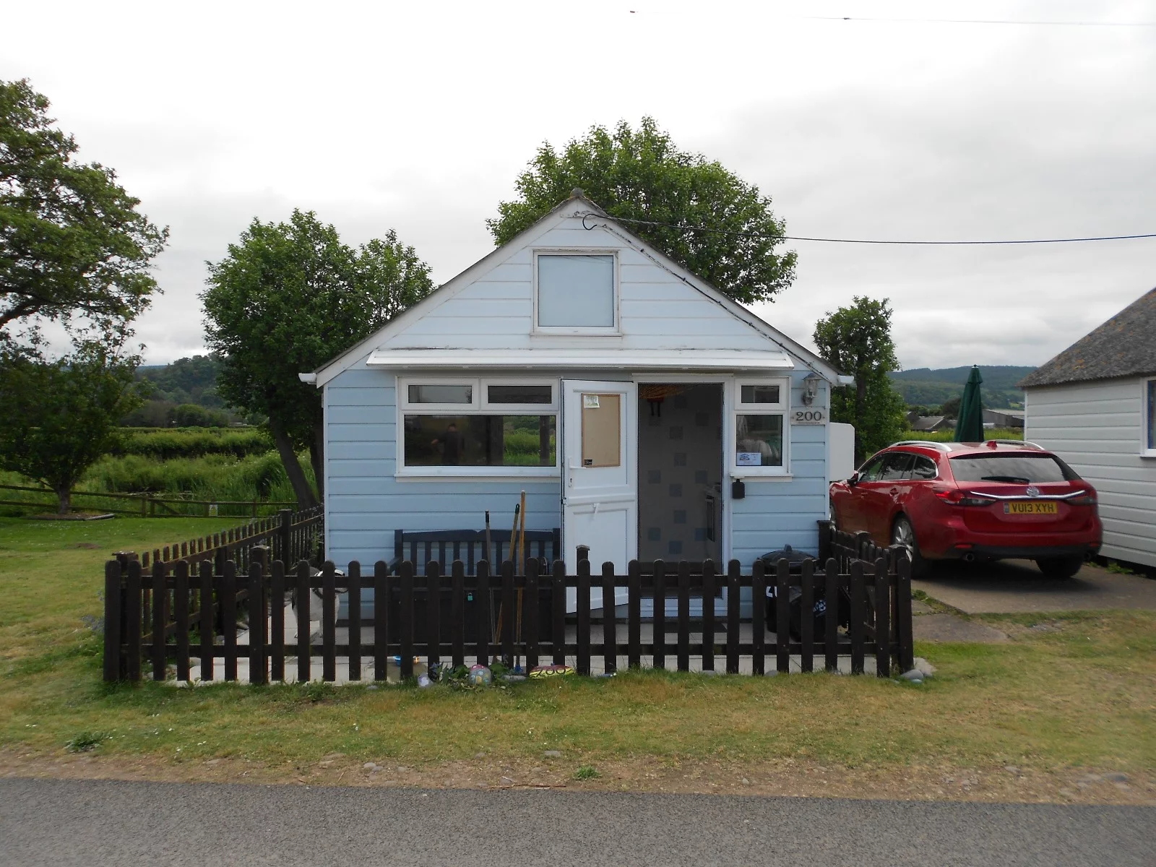

Chalet 200
This lakeside Chalet is about three-quarters of the way along Dunster Beach going towards the Golf Course. From the back of the Chalet you can take in views across the fields and steam train line to Dunster and the Castle.

The Chalet is of UPVC cladding. Double glazed windows. To the front and rear of the chalet are secure and well maintained fencing & gates.

All fixtures and fittings are included in this chalet.

Living Space. Is open plan with fold Away Dining Table and Chairs, lots of storage cabinets and a wall mounted TV. It has a fully equipped kitchen, of which is very spacious with ample of work surface.

Toilet with wash hand basin (no shower). Short walk to the nearest very well maintained shower block.

1 Double Sofa Bed. 1 Double Wall Bed. (when folded away it id hidden discreetly behind curtains) 1 Single Fold Away Bed. Can sleep up to 5 people

Price £175,000
Payment to Dunster Beach Holidays
A fee equivalent to 1.5% of the purchase price and a £50 administration fee are payable to Dunster Beach Holidays. Both fees are subject to VAT
To view the property or for further information, please contact the office on 01643 821296 or
email information@dunsterbeachholidays.co.uk

