CHALET 252 FOR SALE
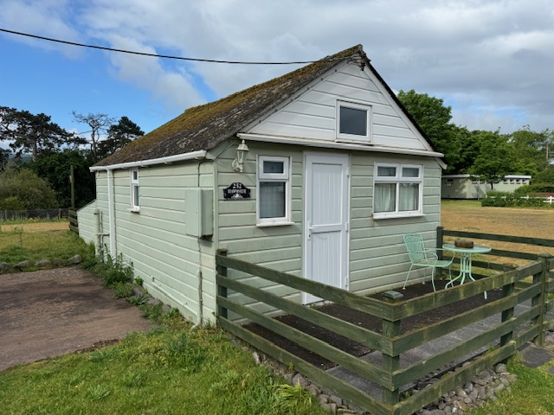

Chalet 252 is situated in a peaceful lakeside location with beautiful views to the rear overlooking ‘The Hawn’ and is just a short stroll away from the beach, café, shop & office. The views from the chalet towards the lake are stunning.
Externally the chalet is clad with UPVC and the roof is corrugated.. To the front and rear of the property there is secure fencing & gates.
This chalet has four concrete support pillars underneath, so gives added rigidity to the structure.
The chalet is double glazed throughout and is double aspect.
The Front of the chalet has a concrete slab offering space for outside seating and a storage box. There is a convenient parking space directly in front of the chalet fence. There is no chalet directly next to the right of the chalet so, this affords a sense of peace and space.
Internally As you walk into the chalet you enter the open plan kitchen which has a hob, oven, dishwasher, sink and ample storage space. A conveniently placed breakfast bar overlooks the lounge area.
There is a double sofa bed to the right, and as this chalet is very open plan, you get a sense of space.
The double bed is to the rear of the chalet on the right hand side, and folds up into the wall when not in use. A fold out table and 2 soft seating chairs just right for relaxing and looking out towards the lake.
To the left of the chalet there is a walk in wardrobe/cupboard and a separate shower and toilet.
Double doors lead out to the large rear patio and garden with ample space for a table & chairs for alfresco dining.
The Chalet is being sold with all fixtures, fittings and contents.

Reduced to £140,000 ono

Payment to Dunster Beach Holidays
A fee equivalent to 1.5% of the purchase price and a £50 administration fee are payable to Dunster Beach Holidays. Both fees are subject to VAT.

To view the property or for further information, please contact the office on 01643 821296 or
email information @dunsterbeach holidays.co.uk
