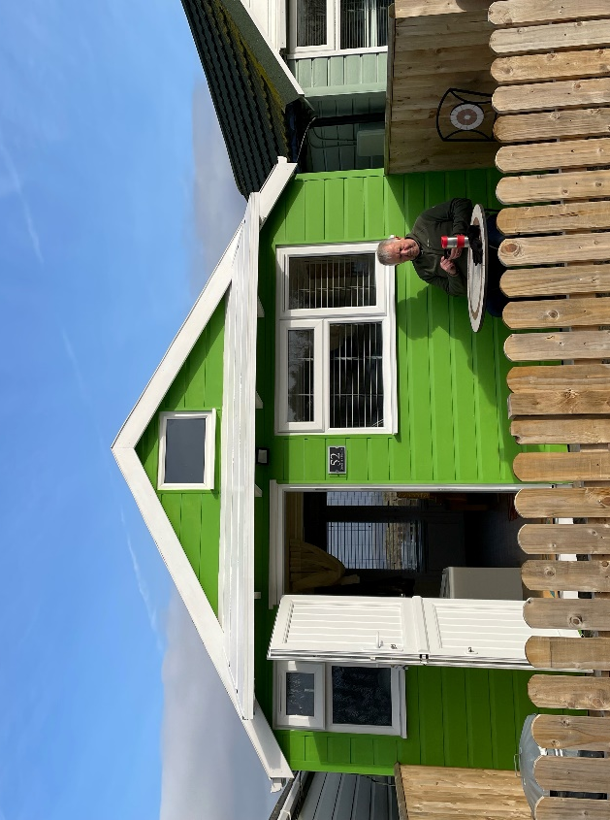
Chalet 52

Beautiful Sea-la-Vie (Chalet 52) is situated seaside with wonderful views across the dunes to the Bristol Channel and onwards to the coast of Wales.
To the front there is parking available directly outside and a patio with table and chairs. Perfect sheltered spot for catching the setting sun.
Beach side there is another patio with storage box and another table and chairs – the sunrise side.
The chalet was completely renovated (photos and copies of invoices available) during 2021/2022 and has recently been repainted outside. All windows and patio doors were replaced and are double glazed. It was also completely rewired and is fitted with USB charging points. The chalet is well insulated and has a shower room and toilet, with a full-size shower cubicle. Front and back patios have also been re-laid.
The layout is open plan with a full-size king-size bed (with storage drawers) which can be accessed from both sides. The bed faces the beach so you can lie in bed and look at the sea!
It is very well equipped with electric oven and hob, under counter fridge with small freezer compartment and microwave. There are ample drawers and cupboards for storage. In addition, there are two armchairs and a fold away dining table and chairs, a wardrobe and more storage for books etc. The smart TV is wall mounted and there is Airband internet available.
A unique feature is the mezzanine storage area which with minor modifications could be used as sleeping area for children. It was built and strengthened with this in mind.
I have come to the sad decision to sell due to new house renovation project that needs all my attention.
£199,000 ONO
Payment to Dunster Beach Holidays
A fee equivalent to 1.5% of the purchase price and a £50 administration fee are payable to Dunster Beach Holidays. Both fees are subject to VAT
To view the property or for further information, please contact the office on 01643 821296 or
email information@dunsterbeachholidays.co.uk
This chalet will be available to Purchase in September 2026

